# Top 10 Best SmartWatches To Choose From (2015)

For a user already having a smartphone what would be the primary need for an another smart device ? Well we think that there plenty of reasons to buy a SmartWatch in 2015.

Most important selling point would be “Ease of Use”. Delivering information instantaneously.

Smart Watches were designed for consumer’s ease of use , portability & simplicity in regards with daily activities they perform on their smartphones.

Consider that you are walking with the smartphone in your pocket, it would be tedious just to get the phone out, unlock it & then do the necessary function. For eg. checking weather, reading SMS, tracking your calories or footsteps, live game scores , maps directions & most importantly checking the time.

SmartWatches from its inception 2013 were brought to consumer’s attention by a Company called Pebble. The hardware & software growth over the past two years in SmartWatches were significant.

Google also made its debut in smartwatches OS with Android Wear which is one of the most talked OS in regards to SmartWatches.

When buying a SmartWatch these four things should be considered for making your SmartWatch purchase the right one.

* Design
* Functionality
* Compatibility
* Specifications

Notable companies in smartwatch industry are Pebble, Motorola, LG & Samsung whose new designs & better functionality paved the way for greater SmartWatch experience to the consumers.

### ****Design****

There are two types of basic Screen designs which we observed with the SmartWatches released so far:

1) Circular Design (Moto 360, LG GWatch)

2) Rectangular Design (Asus Zenwatch, Samsung Gear 2, Sony SmartWatch 2 etc.)

Design standards would be weather the material used was aluminum or plastic build was used.

The Belt which the smartwatch includes is made of plastic, leather or metal.

These would be the key aspects regarding the design of a SmartWatch.

### ****Compatibility****

When buying Smartwatches the user should concern with the smartwatch OS compatibility, for better end results or basic uses of an smartwatch other than just the Time..!!

Google Wear is a platform for android smartwatches.

Pebble was the first smartwatch which made smartwatches mainstream in daily use.

Windows Phones have Microsoft Band as there SmartWatch .

### ****Functionality****

Regarding the functionality of a smartwatch it is entirely dependent on the device you pair & the smartwatch you buy.

Look for potential fitness sensors embedded in the smartwatch , but in 2015 every smart watch maker releases smartwatches with Basic Sensors like 3-axis accelerometer/gyro ,Gyroscope, GPS Ambient light sensor.

Always consider the apps you use daily on your smartphone & check for smartwatches compatibility with that particular app. Eg. Facebook , Twitter Feed apps on particular SmartWatch.

### ****Ease of Use****

The main feature of SmartWatch is to make technology accessible when you need it in an instant without distraction & cumbersomeness. The SmartWatch UI should be slick & intuitive for novice users.

This list will surely improve on your buying decisions regarding SmartWatches you can buy in 2015 & will possibly improve the usage of a smartwatch functions in a better way compared to its big brother “SmartPhone”

## Here is the top 10 Smartwatches to look for in 2015:

## 10) Samsung’s Gear LiveE:\SensehacK Developer\Writings\BeeBom\samsung gear live.png

Samsung makes some pretty good handsets in Smartphone segments & no doubt those flagships phones should have a smartwatch companion. So Samsung brought a good smartwatch which was affordable in terms of other smartwatches.

This is the least expensive Smart watch in android wear categories available today.

It sports an AMOLED display & also a heart rate monitor included in the Gear Live.

The charging adapter is also different from other smart watches.

It weighs about average when compared to other smartwatches & has pretty much above average battery life. It is available officially from Google Playstore.

**Specifications:**

|  |  |
| --- | --- |
| OS : | Android Wear |
| Weight: | 2.12 oz |
| Battery: | 300mAh |
| Memory: | 512MB RAM, 4GB Internal** |
| Display: | 320 x 320pixels 1.63” |
| Display Technology: | Super AMOLED® |
| Connectivity: | Bluetooth 4.0 LE |
| Price : | Rs.15,900 (Playstore) |

<https://play.google.com/store/devices/details/Samsung_Gear_Live_Black?id=samsung_gear_live_black&hl=en>)

## 9) Pebble

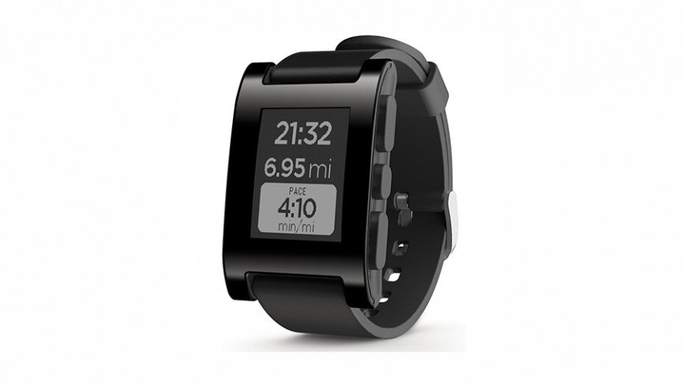

Pebble generally pioneered the smartwatch industry , it was the first to introduce a smartwatch device & its daily functions impacts on our lives.

Pebble was the first device which made non-technical users to crave for a SmartWatch on their wrist.

It is powered by its own Pebble OS , weighs around 38g & superb battery life thanks to the e-paper display it houses with a resolution of 144 x 168 around 1.26”.

The Pebble has more color options than any of the competitors but the build quality is plastic. Recently, Pebble have added much some tweaks to their software, which includes Android Wear Support for notifications

It has standard suite of sensors to run basic functions. The price is also very less compared to its competitors but it has aging technology of 2013 ,so price would be low compared to other smartwatches . Still it is an excellent choice of smartwatch to buy , considering a tight budget in mind.

**Specifications:**

|  |  |
| --- | --- |
| OS : | Pebble OS |
| Weight: | 38g / 1.34oz |
| Battery: | Up to 7 days between charges |
| Memory: | RAM 128 KB, 8 mib (MB) |
| Display: | 1.26-inch, 144 × 168 pixel e-paper display |
| Display Technology: | LED backlight |
| Connectivity: | Bluetooth 4.0 |
| Price : | Rs. 9,764.00/- |

(<http://www.amazon.in/Pebble-E-Paper-iPhone-Android-Devices/dp/B00BKEQBI0>)

## 8) Sony SmartWatch 2

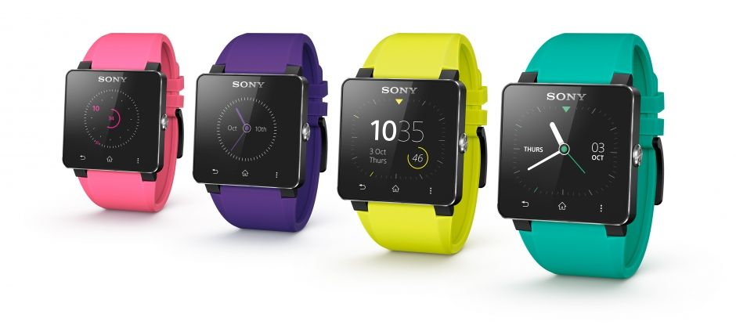

Sony SmartWatch 2 was a good successor to Version 1. Improved battery life with Micro USB charging & Media Related Features for controlling Media & standard set of daily functions embedded in this product.

All in all a fine product only if you are on Tight Budget as Sony SmartWatch 3 has been revealed & available in India One might consider the Successor of this product.

Sony smartwatch is heavy to begin with but it has better connectivity options.

Its battery life is above average, processing speed is mediocre but what it stands out is for good colour options & NFC connectivity.

**Specifications:**

|  |  |
| --- | --- |
| OS : | Not revealed |
| Weight: | 122.5 grams |
| Battery: | Upto 4 days |
| Memory: | Not revealed |
| Display: | 1.6 inch” 220 x 176 |
| Display Technology: | Transflective LCD Display |
| Processor: | 200 MHz |
| Connectivity: | Bluetooth v 3.0 Connectivity , NFC |
| Price : | Rs.8,940/- |

(<http://dl.flipkart.com/sony-smartwatch-men-women/p/itmdzyy4phng3gsg?pid=WATDZYYYYBNPBNMN&srno=b_9&ref=8d6833c9-5f3d-4c78-8cdf-d63c411cc166>)

## 7) Microsoft Band

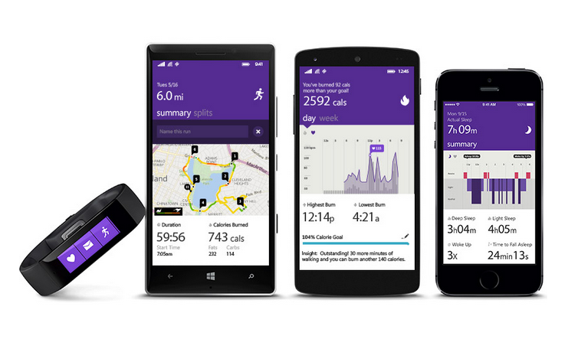

It is the first smartwatch from Microsoft & also the first device to support Windows Phones.

This smartwatch “Band” has different approach in terms of display design & user interactivity. It is neither square nor circle but rather it is an elongated rectangle which looks like an actual fitness band.

Its small, lightweight & supports all major Smartphone OS. “Cortana” Personal Assistant of Microsoft is also available for Windows Phone 8.1 users. Some Features require Lumia Denim update.

Microsoft Band is a fitness band created and developed by Microsoft, and released in very limited quantity on Microsoft Store. Its still not available in India Officially.

The band supports 10 sensors which includes Optical heart rate sensor , 3-axis accelerometer, Gyrometer, GPS ,Ambient light sensor ,Skin temperature sensor, UV sensor ,Capacitive sensor ,Galvanic skin response, Microphone.

The battery life is good with 2 days of normal usage.

More information on (<http://www.microsoft.com/microsoft-band>)

**Specifications:**

|  |  |
| --- | --- |
| OS : | Microsoft's wearable architecture |
| Weight: | 2.12 ounces (60 g) |
| Battery: | 48 hours Dual 100mAh |
| Memory: | 2MB of RAM, 64MB internal storage |
| Display: | 1.4" 320 x 106 pixels |
| Compatibility: | Works with Windows Phone 8.1, iOS 7.1 and later: and Android 4.3 |
| Display Technology: | TFT full color display |
| Connectivity: | Bluetooth 4.0 LE |
| Sensors: | Optical heart rate sensor , 3-axis accelerometer, Gyrometer, GPS ,Ambient light sensor ,Skin temperature sensor, UV sensor ,Capacitive sensor ,Galvanic skin response, Microphone. |
| Price : | $199 |

## 6) Pebble Steel

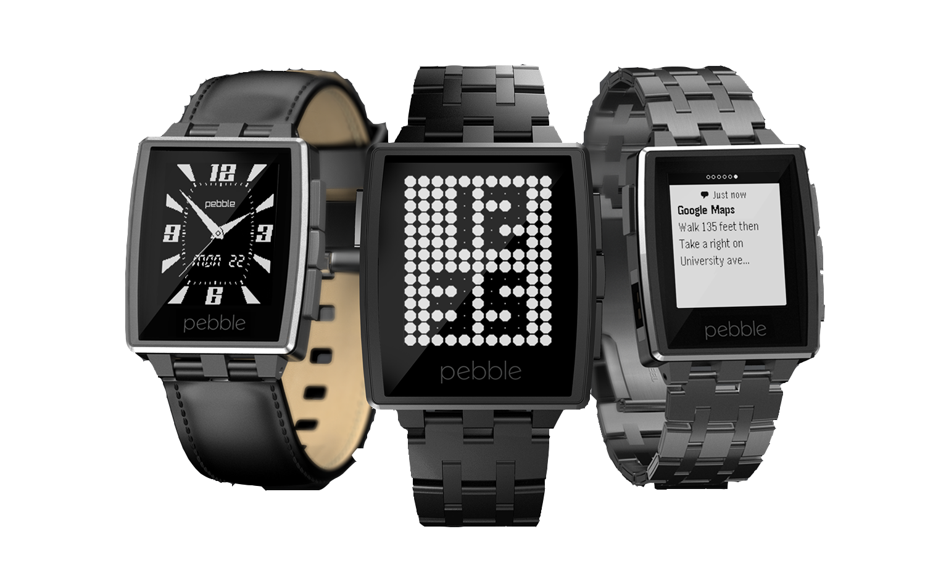

Pebble steel is the device every smartphone or professional business owner would love to buy it.

The name itself justifies that its primary material of smartwatch is Steel & the watch does a pretty good job at appealing business users & people with high aesthetic choice over plastic body.

The Pebble Steel is a better advancement of the original Pebble.

Pebble Steel lacks a high resolution screen or colourful display & that square design may not be appealing to everyone but the build quality just screams Premium & it also provides excellent battery life.

The excellent battery life is provided due to the use of e-paper display technology which minimizes the battery usage as it produces less amount of color gamut but it offers better screen readability at night , thus not damaging your eyesight.

Choose this SmartWatch if Android Wear is not your cup of tea or if you want more device compatibility.

Price is higher than the original Pebble & it is also heavy in terms of weight of the smartwatch.

**Specifications:**

|  |  |
| --- | --- |
| OS : | Pebble OS |
| Weight: | 56g / 1.97oz |
| Battery: | Up to 7 days between charges |
| Memory: | RAM 128 KB, 8 mib (MB) |
| Display: | 1.26-inch, 144 × 168 pixel e-paper display |
| Display Technology: | LED backlight |
| Connectivity: | Bluetooth 4.0 |
| Price : | Rs.21,990/- |

(<http://www.amazon.in/Pebble-iPhone-Android-Devices-Leather/dp/B00IVX0XGO>)

## 5) Motorola Moto 360

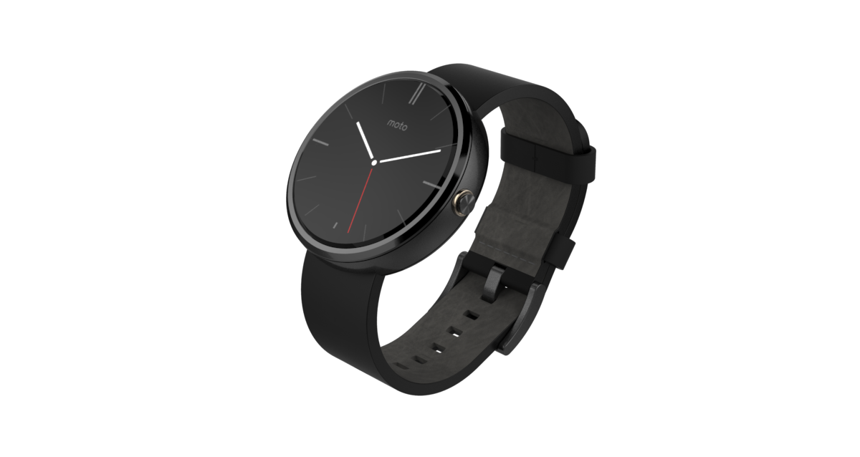

Moto 360 could seriously turn heads with its Round watch design & luxurious build quality with affordable price tag. You could never go wrong with this SmartWatch.

It deserved Number 3 Spot, but due to its lower resolution , lesser battery life & black section at the bottom of the screen made us think again about the potential flaws in this product.

This Smart Watch is for the people who love Retro Watches Round Design .

The black strap which comes as default is a perfect craftsmanship of technology with round edges.

The watch also has Gorilla Glass 3, Heart Rate Monitor & comes standard as Water Resistant smartwatch.

It weighs about average & Android Wear OS is a huge selling point for this smartwatch.

The Pedometer helps in tracking the steps you took in the daily session , a fitness sensor.

**Specifications:**

|  |  |
| --- | --- |
| OS : | Android Wear |
| Weight: | 49 g |
| Processor : | TI OMAP |
| Battery: | 320 mAh |
| Memory: | 512MB RAM, 4GB Internal |
| Display: | 1.5-inch Display Size” 320 x 290 pixel |
| Display Technology: | Backlit LCD |
| Sensors : | Heart Rate Monitor ,Pedometer |
| Connectivity: | Bluetooth 4.0 LE |
| Price : | Rs. 17,999 /- |

(<http://www.flipkart.com/motorola-moto-360-smartwatch/p/itmdzrf56agybrvt>)

## 4) Sony SmartWatch 3E:\SensehacK Developer\Writings\BeeBom\smart watch 3.jpg

Sony Smart Watch 3 is a nice upgrade from the Smart Watch 2. Software change would be from earlier Sony proprietary OS it has moved its hardware to Android Wear OS.

It has pretty standard specifications as required by Android Wear OS. Smart Watch 3 from Sony is one of the few watches which has GPS in built, which makes it easily usable for Fitness related apps without having to carry a phone around with you.

Battery life is improved over the Smart Watch 2 but still the battery life leaves us lot to be desirable. Turn on the GPS & battery drains quickly.

The new Metal version & strap adapter makes this SmartWatch more appealing than its predecessor.

The internal memory is also visible this time so plenty of storage available for Android Wear apps to be installed. Price is higher than its previous smartwatch 2 as it is new & supports Android Wear which is a huge selling point for sony , unlike smartwatch 2 had its own OS.

**Specifications:**

|  |  |
| --- | --- |
| OS : | Android Wear |
| Weight: | 45 g |
| Battery: | 420mAH |
| Processor: | 1.2GHz ARM A7 quad core |
| Memory: | 512MB RAM, 4GB internal memory |
| Display: | 1.6 inch” 320 x 320 |
| Display Technology: | Transflective LCD Display |
| Connectivity: | Bluetooth 4.0 Connectivity , NFC |
| Price : | Rs.16,989/- |

(<http://www.amazon.in/Sony-SmartWatch-3-SWR50-Black/dp/B00P7ATIR4/ref=sr_1_1?s=electronics&ie=UTF8&qid=1426053559&sr=1-1&keywords=smartwatch+3>)

## 3) Samsung Gear 2

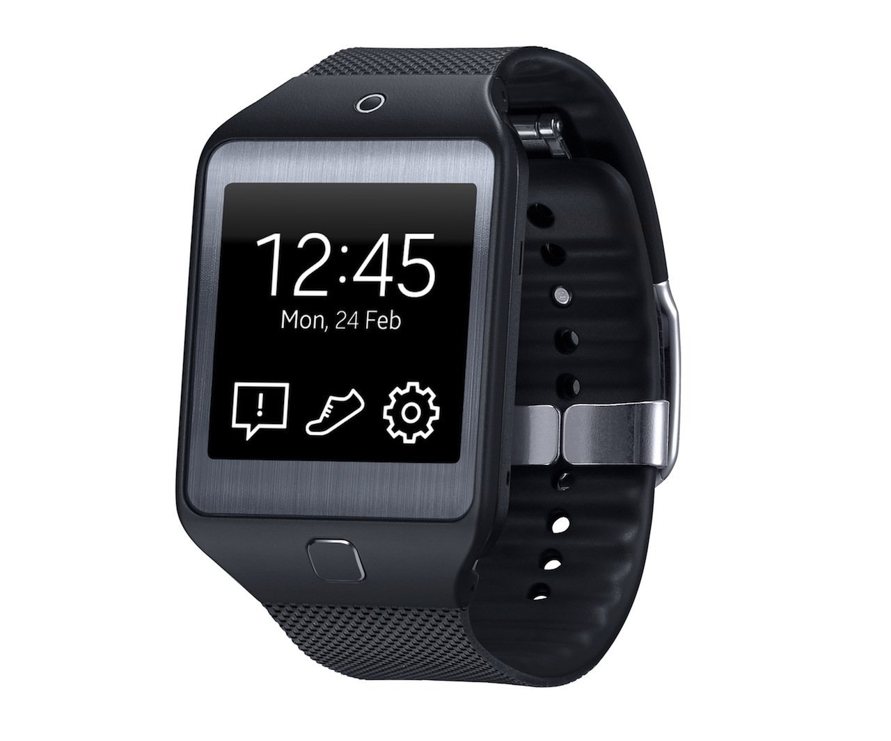

Samsung Gear 2 was announced at the same event as the Galaxy S5 & the biggest pain with this device is it won’t work with any other Smartphone other than a Samsung Smartphone, but still the offering by this smartwatch is a great must have accessory for die-hard Samsung fans.

This smartwatch has an integrated Camera which is what makes this Smartwatch different from its competitors. Not that the camera on smartwatch would be useful in everyday scenario considered in smartwatches , but it still has one. It also comes with range of Sensors embedded in the smart watch & the most useful would be Heart-rate sensor used for tracking your heart beats.

With a camera, heart-rate monitor and some other interesting features this smartwatch is worth the money it offers . Featuring a built-in microphone and speaker which would be useful to attend a call without using a smartphone.

Device is powered by 1.0 GHz dual-core Exynos 3250 which is pretty good processor & it is lighter than earlier Samsung Gear.

The OS this watch comes with is a Tizen OS which has a major drawback of only supporting Samsung Smartphones.

**Specifications:**

|  |  |
| --- | --- |
| OS : | Tizen |
| Weight: | 2.12 oz |
| Processor: | 1.0 GHz dual-core Exynos 3250 |
| Battery: | 2~3 days |
| Memory: | 512MB RAM, 4GB Internal** |
| Camera: | 2.0 Megapixel Auto Focus |
| Display: | 320 x 320pixels 1.63” |
| Display Technology: | Super AMOLED® |
| Compatibility: | Works with Samsung Smartphones only |
| Sensors: | Accelerometer, Gyroscope, Heart Rate Sensor. |
| Connectivity: | Bluetooth 4.0 LE |
| Price : | Rs. 28,990 /- |

(http://www.amazon.in/Samsung-Gear-2-Charcol-Black/dp/B00O9YS8P2/ref=pd_sim_sbs_e_21?ie=UTF8&refRID=1QX2Q32YH9ZNHSBQND5Y)

## 2) LG G Watch R

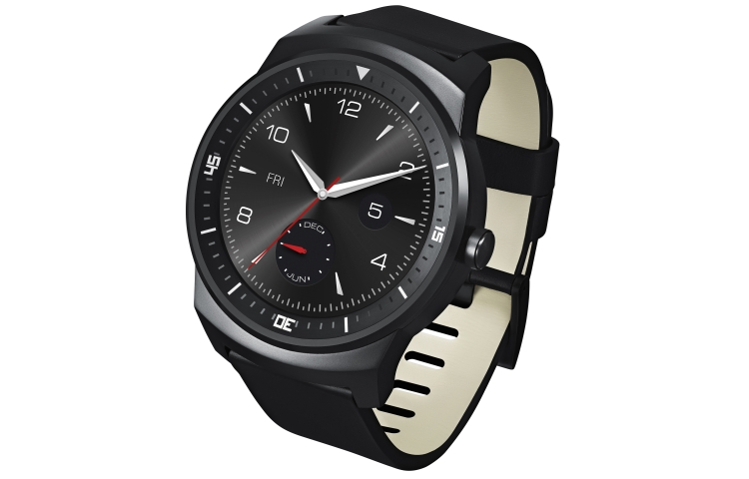

LG G Watch R packs amazing specification & with that round design which the watch has inspires every other SmartWatch manufacturer to adapt this round design.

It has full circle display unlike the Moto 360 , but the display is so much better than other smartwatches in comparison. It has better battery life than the Moto 360 thanks to a bigger 410Mah battery & always ON display.

The watch is also pretty light compared to its competitors, it also has dust & water resistant display.

Powering the device is by a Qualcomm Snapdragon 400 processor with 4 GB internal memory & 512MB Ram.

The display technology used in this smartwatch is also different than other competitors which is P-OLED.

Still it is one of the expensive smartwatches you could buy.

**Specifications:**

|  |  |
| --- | --- |
| OS : | Android Wear |
| Weight: | 62 g |
| Battery: | 410 mAh |
| Processor: | CPU Qualcomm® Snapdragon™ 400, 1.2GHz |
| Memory: | 512MB RAM, 4GB Internal |
| Display: | 1.3” Full Circle |
| Display Technology: | P-OLED |
| Connectivity: | Bluetooth 4.0 LE |
| Sensors: | 9-Axis (Gyro, Accelerometer, Compass), PPG (Heart rate monitor), Barometer |
| Price : | Rs. 14,999./ |

## 1) ASUS ZenWatch

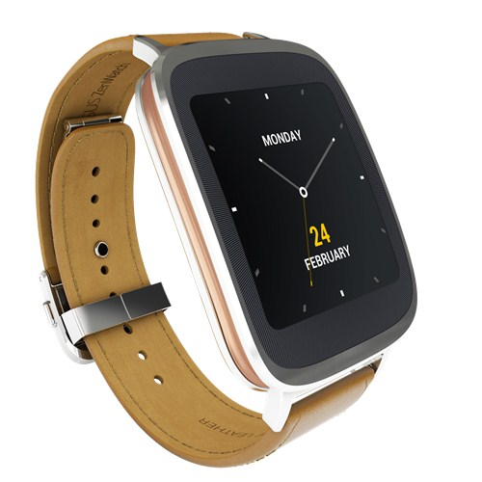

The first rank goes to Asus Zenwatch due to excellent design with good specifications on a smartwatch.

There is nothing wrong with the circle smartwatch like Moto 360 & LG G Watch R, but the ZenWatch comprises of best aesthetic looks, design, brushed aluminum frame & premium Italian leather watchband which makes the ASUS ZenWatch the best SmartWatch amongst its competitors you can buy in 2015.

Metal Strap Fans could easily swap in a bracelet.

It houses Qualcomm Snapdragon 400 1.2GHz which is capable for doing most of the daily computations on a SmartWatch. The display comprises of Gorilla Glass 3 with Water Resistant & AMOLED 1.63"320x320, 278ppi Touch Display packed with good battery life makes daily tasks as a breeze.

This Smartwatch would even appeal to the Business class as the build quality is top notch coupled with the leather bracelet, which gives a classic look for Suits & Ties.

This smartwatch is here to stay the number one watch for some time atleast till Apple Watch makes an stellar appearance & users would love apple’s ecosystem of apps.

But till Apple releases its SmartWatch we have our winner “ASUS ZenWatch”

**Specifications:**

|  |  |
| --- | --- |
| OS : | Android Wear |
| Weight: | Body : 50 g , Strap : 25 g |
| Battery: | 2 Days (Polymer 1.4Wh) |
| Processor: | CPU Qualcomm® Snapdragon™ 400, 1.2GHz |
| Memory: | 512MB RAM, 4GB Internal |
| Display: | 1.63" 320x320 |
| Display Technology: | AMOLED |
| Connectivity: | Bluetooth 4.0 |
| Sensors: | 9 Axis Sensor/Bio sensor |
| Price : | Rs 22,579/- |

( <http://www.ebay.in/itm/like/171670775967>)

## Most Anticipated Smartwatch

## Apple iWatch

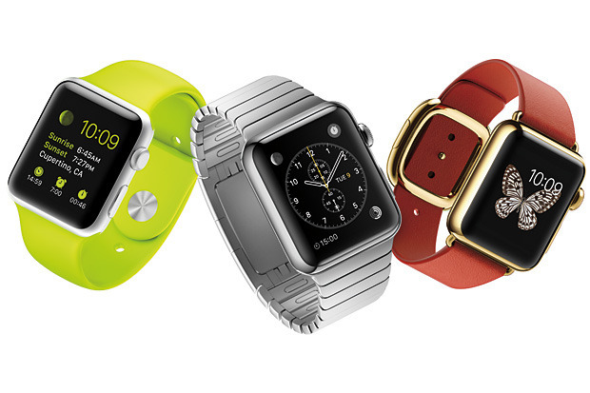

The Apple Watch will be available to preorder on April 10, and on sale April 24. It will initially be available in nine countries, including UK, Australia, China, Japan, Hong Kong, Germany and France

Three variants are available :

* Apple Watch Sport
* Apple Watch
* Apple Watch Edition

### Apple Watch Sport

Apple Watch Sport comes with a fluoroelastomer (synthetic rubber) band, and has an aluminum-alloy body (silver or space gray), Ion X-strengthened glass and composite back. It costs $349 for 38mm, or $399 for 42mm sizes.

### Apple Watch

Apple Watch (the mid-tier model) comes in stainless steel with a sapphire crystal and ceramic back. There are two colors (steel and space black steel), and a number of pre-packaged or separately-sold bands. It starts at $549 (38mm) or $599 (42mm). Depending on which one you pick, you could pay anywhere from $549 to $1100.

### Apple Watch Edition

Apple Watch Edition has an 18-karat gold (rose gold or yellow gold) body with sapphire crystal and ceramic back and starts at $10,000, with options ranging all the way to $17,000.

Confusing Right ? Yes there are Three types of Apple smartwatches , it ranges from $349 all the way upto $17000.

The accessories are also optional with a plethora of interchangeable bands to pick from colours , types , locking systems, materials etc.

Apple Pay is the Feature which makes it unique currently so you can pay at stores without drawing out your iphone from your pants or bag & simply tag your apple watch just like an id card barcode verification.

It has haptic feedback which is a "taptic engine" that feels like more advanced and subtle vibration just like an actual human touch sensitivity by a finger . It also has a force-sensitive display: press harder, and it will do different things

Digital Crown would be used for zooming in & out of applications , photos , maps & many more.

For more information ,

(https://www.apple.com/in/watch/apple-watch/)

## About the Author

**Kautilya Save**:

Technophile(Geek),Photographer,Enthusiast,Good Managing Sense,Loves Cooking,Enjoys Travelling different places & a Professional Gamer.

Currently pursuing Computer Engineering Degree in D. J. Sanghvi College of Engineering (Mumbai).

Have Passion for Computing & Following Photography as a Hobby.

Gamer Tag : (^$enseh@cK^)

Facebook Link (<https://www.facebook.com/sensehack>)

Twitter Link (https://twitter.com/kautilyasave)

111111

http://www.pcadvisor.co.uk/test-centre/wearable-tech/3497103/13-best-smartwatches-2015-uk/